Cover Page
Subject name/code:
Web Development (Introduction) WEDE5020 2026 FT BIT0
Name & Surname:
Ethan Ntuli
Student number:
ST10508782
Group:
1

Contents
Cover Page 1
1. Organisation Overview: 3
2. Website Goals and Objectives: 4
3. Current Website Analysis (if applicable): 4
4. Proposed Website Features and Functionality: 4
5. Design and User Experience: 5
6. Technical Requirements: 6
7. Timeline and Milestones: 6
8. Budget: 7
9. References: 7

1. Organisation Overview:
- Name: [Football Academy Plus Bruma]
- Provide a brief history of the organisation.
There isn't a lot of published information about the history of Football Academy Plus Bruma, but what is available gives a general idea:

In Bruma, Johannesburg, there is a football training organization called Football Academy Plus Bruma. It is a sports development academy that helps young football players grow and encourages more people to play the sport.

The academy has been around since at least 2019, which is the earliest proof that it was a working organisation.
It is located at 26 Hans Pirow Road, Bruma, and is part of the local sports club scene. (Football Academy Plus Bruma, 2025) The main job of the organization is to give football training, coaching, and development opportunities, especially to young players.
- Mission and vision statements.
The mission is to give young players the best football training possible that builds their technical skills, discipline, and teamwork, and helps them reach their full potential on and off the field.

The vision is to be a top football academy in Johannesburg, known for training players who are up and coming talent as well as confident, and responsible, and who do well in football and make their communities better.
- Target audience.
Football Academy Plus Bruma is for boys and girls between the ages of 6 and 18 who want to learn and improve their football skills. This includes people who are just starting out in the sport, as well as intermediate and advanced players who want to get better and compete at higher levels.

The academy also aims to help talented people who want to play football professionally, as well as parents and guardians who want a structured and supportive place for their kids to grow physically and mentally. The academy also has a wider audience, which includes schools, local teams, and people in the community who are interested in youth development and sports programs.

2. Website Goals and Objectives:
- Define specific goals for the website (e.g., increase website traffic, generate leads, sell products, or provide valuable information).
Football Academy Plus Bruma's website seeks to advertise the academy, draw in new players, and offer crucial details regarding programs and training. Additionally, it encourages community engagement, player development, registration, and growth through partnerships. (Football Academy Plus Bruma, 2026)
- Determine and present key performance indicators (KPIs) to measure success.
The number of visitors, registrations, user engagement, inquiries, and the number of people who take action after visiting the website will all be used to bring up the clubs success. These metrics demonstrate how well the website draws in visitors and turns them into players. In order to boost overall performance, they also assist in identifying areas that require improvement.

3. Current Website Analysis (if applicable):
- Analyse strengths and weaknesses of the existing website.
Weaknesses
There is no website and people might be looking for information on the academy to get a better understanding on what the clubs morals are. The club not providing information for visitors may lead to less customers. When a website takes long to load. The website wont show any images of what they are offering.
- Identify areas for improvement based on the weaknesses identified.
The website's design should be updated to make it more current and aesthetically pleasing in light of the flaws found. Simplifying navigation will make it easier for users to locate information. Moreover, the website should be optimized for quicker loading times and made mobile-friendly.

4. Proposed Website Features and Functionality:
  - Outline essential features (e.g., homepage, about us, contact page, products/services page) and the desired functionality.
Homepage About Us Page: This page should describe the academy's role as a sports organization that provides football development in Johannesburg. The mission, objectives, and what sets the academy apart from other local clubs can all be included.
Services/Programs Page
This page should outline the football training services provided (skills training, age groups, schedules) so parents and players know what to expect. It can also provide general information about how sessions are organized and what players learn, even though comprehensive program information isn't commonly listed online.
Contact Details:
(084-836-1091) and address (26 Hans Pirow Rd, Bruma, Johannesburg, 2026, South Africa).

5. Design and User Experience:
  - Discuss the overall design aesthetic and branding, highlighting the following:
  - Colour Scheme: [The suggested colour scheme is green, black, and white, they reflect vitality, development, and professionalism while maintaining the site's sporty image.]
  - Typography: [Mongolian Baiti for headings, Arial for the plain body.]
  - Layout and Design: [A grid-based layout will be used for sections such as programs, gallery, and contact information, and the design will be simple and contemporary. Consistent branding and styling components, such as the logo and colour accents, will appear on every page.]
  - User experience considerations (With a clear menu, a mobile-friendly layout, and easy access to registration and contact forms, navigation will be straightforward. Finding information will be simple thanks to the site's natural navigation provided by the colour scheme and typography.).
  - Develop low-fidelity wireframes to visualise the website's layout and information hierarchy.
Header (appears on each page)

On the left is the logo
Home | About Us | Programs | Gallery | Contact | Register is the navigation menu.

2. Homepage (Section on Heroes)

A sizable picture of players in action
"Welcome to Football Academy Plus Bruma" is the headline.
Call-to-action buttons: [Learn More] [Register Now] (Football Academy Plus Bruma, 2026).

3. The "About Us" page

A picture of the academy or coaches
Text section outlining the mission, vision, and values of the academy

4. Services and Programs Page

Sections devoted to:
Training Courses, Age Groups, Timetable, and Costs

5. Media/Gallery Page

Grid of photos from practice and games
Highlights from the Academy in an optional video section

6. Registration and Contact Page

Name, email, phone number, message, academy address, and map are all included in the contact form.
Email address and phone number for inquiries

7. Footer (found on each page)

6. Technical Requirements:
- Identify hosting and domain name requirements and programming languages and frameworks (e.g., HTML, CSS, JavaScript).
Domain: www.footballacademyplusbruma.co.za.
Hosting: Truehost
Programming languages and frameworks: Html structure to develop the way the Website should appear (Truehost, 2025; xneelo, 2026). Ill use advanced CSS for styling and creativity in the website.

7. Timeline and Milestones:
  - Create a realistic project timeline with key milestones that follow the timeline during the subject's submission dates.
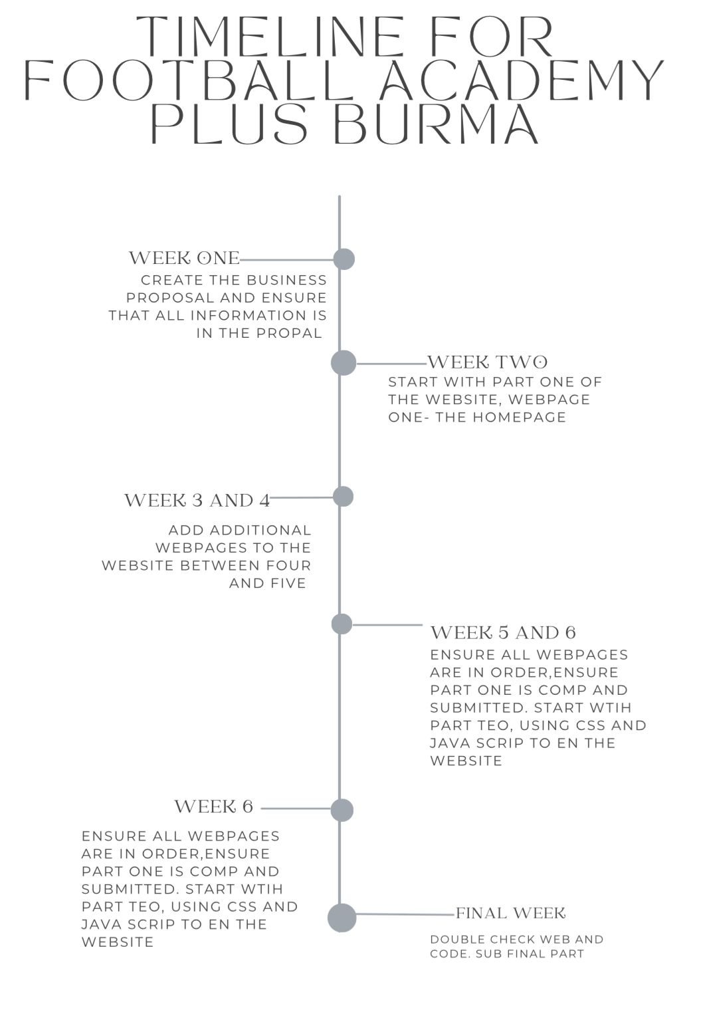

8. Budget:
  - Estimate the budget for development, hosting, and maintenance (while this is a series of assignments, the budget should reflect realistic amounts based on your research).
Domain Name: Registering a domain like www.footballacademyplusbruma.co.za will cost around R200 to R400per year.
Hosting: A shared hosting plan with providers like HostAfrica, Truehost, or xneelo will cost approximately R500 to R1,500 per year.
Development Tools: Optional tools, such as WordPress themes, templates, or plugins, may cost between 0 and R1,000 one-time.
Media and Graphics: Stock images, logos, or image editing tools could cost up to R500, depending on the resources used.
Maintenance: Minor updates, backups, and content changes may cost about R200 to R500 per year. (Domains.co.za, 2026).
(CHATGPT: Development.tools.)

9. References:
  - References listed here are unique to the chosen organisation and the researched documentation of the Website Project Proposal. The references listed in this document and the general references used to complete Part 1 will be compiled in the README.md document in the repository for the entire PoE.
I used chatgpt as refrence:
Football Academy Plus Bruma (2026) Football Academy Plus Bruma | 084 836 1091 | Johannesburg, Africabizinfo. Available at: https://www.africabizinfo.com/ZA/football-academy-plus-bruma-084-836-1091 (Accessed: 29 March 2026).
Football Academy Plus Bruma (2025) Football Academy Plus Bruma - 26 Hans Pirow Rd, Bruma, Johannesburg, South Africa, Cybo. Available at: https://www.cybo.com/ZA-biz/football-academy-plus-bruma (Accessed: 29 March 2026).
Truehost – Cheapest Web Hosting and .co.za Domains in South Africa (2025). Truehost. Available at: https://www.truehost.co.za/hosting (Accessed: 29 March 2026).
Domain & Web Hosting South Africa (2026). Domains.co.za, Web Hosting Packages. Available at: https://www.whtop.com/plans/domains.co.za/141608 (Accessed: 29 March 2026).
xneelo Web Hosting Services (2026). xneelo. Available at: https://xneelo.co.za (Accessed: 29 March 2026).

Html pictures:
https://encrypted-tbn0.gstatic.com/images?q=tbn:ANd9GcSjUYnXn0bAlmo2w_yrorO6fheTTbtb_FTwMg&s (product 5)
https://www.californian.co.za/wp-content/uploads/2022/10/A786-K7-BLACK_WHITE_GREEN-PREDATOR03.jpg (product 6)
https://www.justbrand.co.za/cdn/shop/files/SoccerSectionfromtenthSport-40.png?v=1759999788&width=1080 (product 4)
https://sfida.com.au/cdn/shop/files/COMPRESSION_LONGSLEEVE_MENS_BLACK_S1.jpg?v=1757560707 (Product 3)
https://m.media-amazon.com/images/I/71bW0oe1vGL._AC_UF1000,1000_QL80_.jpg (Product 2)
https://encrypted-tbn0.gstatic.com/images?q=tbn:ANd9GcRV13RWW3BihAaVeF69K7uOnSM2w-ahQHQ9Yw&s (Product 1)
https://encrypted-tbn0.gstatic.com/images?q=tbn:ANd9GcSOtdI_bGG1I01RpKMdYfSq1-JDuGH4dnjUeQ&s (Plus 3)
https://encrypted-tbn0.gstatic.com/images?q=tbn:ANd9GcRHl0SjyMpts2mMzicLp4Or6jrdNVN1dEwcfw&s (Plus 2)
https://encrypted-tbn0.gstatic.com/images?q=tbn:ANd9GcSvZN4K-mGiMPsCpyLnlo4sRkGb5QnulwWADg&s (Plus 1)

